Group Project Plan

**Platform Supervising System with Blockchain**

**Group member**: Zhongxin Li, Kexin Xu

**Use case**: We are a platform for supervising and managing some Sharing Economy System. Trying to fix the trust problems between company and consumers by blockchain.

**TimeLine:**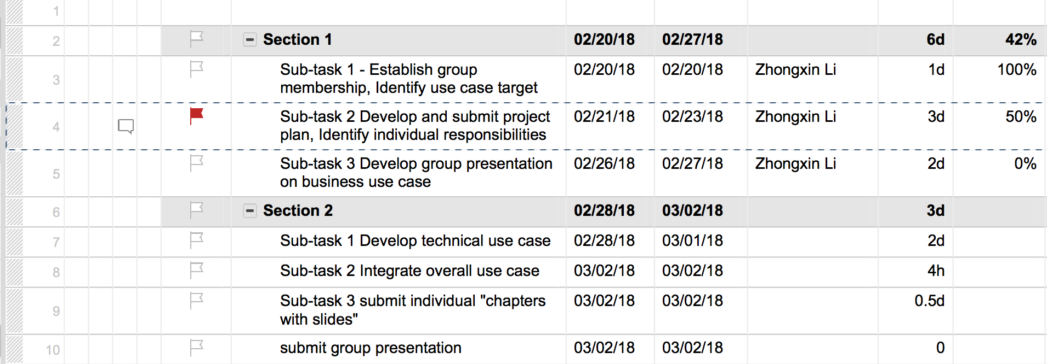

**Individual responsibilities:**

Case study:

Kexin Xu: bicycle-sharing system, Uber

Zhongxin Li: charger-sharing system

**Introducing**

Congruence between the image a company portrays externally and the way it operates internally is critical today. People are pulling back the curtains on companies and revealing how well, or not, their internal cultures are aligned with external images.

People only want to associate themselves with brands that reflect their personal values. And with more than enough options to choose from in any given category, customers easily and quickly shift their loyalties when they perceive any cognitive dissonance.  A company that doesn't integrate its culture and its brand may go undetected for a while -- but eventually customers will discover the lack of alignment lose all trust and respect for the brand.

In this sense, our platform is an easy way to fix the trust problem between the companies and costumers. For costumers, we keep track and record the performance of the company, eliminate the possibility that the company may delete or distort the data and our platform provide a place for customers to protect their own rights and interests. The most important thing is they can get the feedback efficiently from the platform.

For company, they do not need cost much money and time to root causes, all the data are trackable in our system, also they do not need to pay much money to supervise staffs, our system can help them to regulate employee performance and behavior.

All in all, our platform can improve the share-economy system, no matter from business and technical. Our first step is implementing the data recording with blockchain technology, then we will try to launch our platform, the last step is issuing our own token.

Keywords: image of a company, trust, respect, track and record, distort the data, feedback, platform, supervise, employee performance and behavior, token

Bicycle-sharing system:

Problem:

Disorderly parking: according to my observation during the time I was in china, it is normal that different colors sharing bike parked disorderly in front of the entrance of metro station, some even just park in the middle of the bicycle lane and sidewalk.

Dead bike problem: In some bustling commercial center, during the peak period, the bike using will have the one-way phenomenon, it cannot form a cycle use. Many costumers just park the bike as will, without thinking the next costumer who may not find the bike easily.

Keyword: disorderly parking, dead bike problem

Stack-free

Uber:

Problem (Sexual Harassment):

Over the last seven years, Uber has done everything possible to continue using low-cost, woefully inadequate background checks on drivers and has failed to monitor drivers for any violent or inappropriate conduct after they are hired. Earlier this month, Uber pledged $5 million during the next five years to fund sexual assault prevention groups as well as train its own employees. Uber says the groups have helped it train 150 customer service agents for a team to deal with sexual assault reports. They’ve learned how to interview victims without being judgmental, and how to refer them to police and a crisis hotline.

Keywords: Uber, monitor, drivers, sexual assault prevention, $5 million, customer service

Associated Press.(2017.November.14).2 Women sue Uber alleging sexual assault by drivers. New York Post. Retrieved from https://nypost.com/2017/11/14/2-women-sue-uber-alleging-sexual-assault-by-drivers/

Denise Lee Yohn.(2017.March.25). Why Did Sexual Harassment Fell Uber, Forbes. Retrieved from https://www.forbes.com/sites/deniselyohn/2017/03/25/why-did-sexual-harassment-fell-uber/#e07ea5420507